HYBRID POWER 40KVA/60KWH 1PH 240

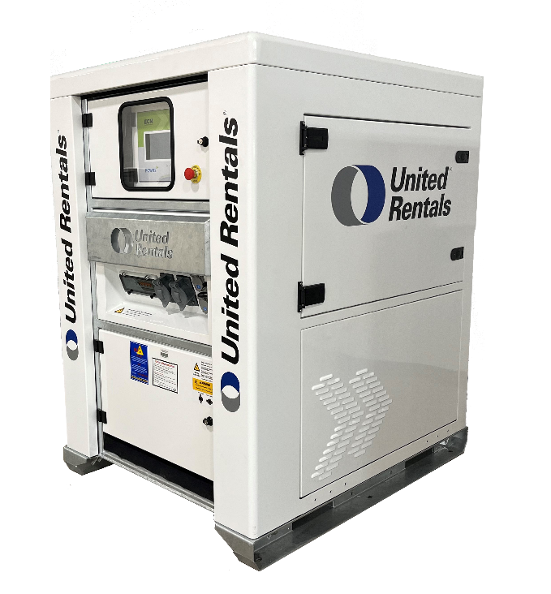

Clean, Reliable, Portable Energy Storage
Decrease Fuel Consumption, Eliminate Noise, Reduce CO₂ Emissions, Improve Energy Efficiency

Features  - Intelligent onboard energy control module that communicates with the generator  - Flexible maneuverability options with forklift pockets, lift & drag skid and lifting ring  - Monitor and manage energy online | Benefits  - Environmentally friendly, helps in meeting emissions regulations and sustainability goals  - Save on fuel, reducing both CO₂ emissions and costs  - Increases reliability as it manages variable loads and eliminates light load periods  - Delivers zero noise, ideal for projects where sound needs to be kept to a minimum

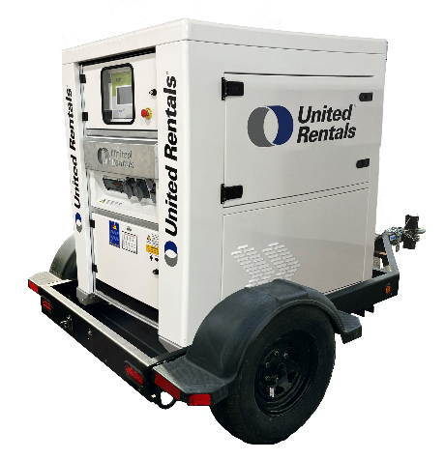
General
CAT / CLASS | 240-4830
Manufacturer
Unit Model Number | P40.60/240
Equipment Insurance Value | $
Dimension | 1140 mm x 1450 mm x 1580 mm (L/W/H)
Unit Weight (Est.) | 1360kg
Trailer Type | Single Axle Trailer

Electrical
Single Point Power Supply | Input: 240 (200-280) V Output: 120V/240 V, 60Hz – Split Phase
Connections | CAM Type Connectors, Power Terminals & NEMA (5-15P) 15A 120V inlet  CAM Type Connectors, Power Terminals & NEMA (5-15P) 15A 120V outlet
Output Power | 40kVA - (30min), 32kW Nominal
Nominal Capacity | 56kWh
Charge | 7hr15 @ 16kW
Discharge Time | 5hr30 (External Source + Storage) ,2hr15 (Storage)
Maximum Output Current(A/ph) | 300A (External + Storage), 96A@240V, 190A@120V (Storage)
Life Cycle/Charge Cycle | 6000hr / <3 Weeks
Control & Communication | ECM 7” Touch Screen Module – 3G/4G Dual Sim Modem/Router, Powr2 Portal
Operating Temperature Range | 10 – 122 ⁰F
Water/Ingress Protection Rating | NEMA 3, IP55
Battery Chemistry | LFP Batteries with BMS

Charge Curve
Charge time within a nominal temperature range is approximately three hours

Discharge Curve

