HYBRID POWER 60KVA/120KWH 3PH 208

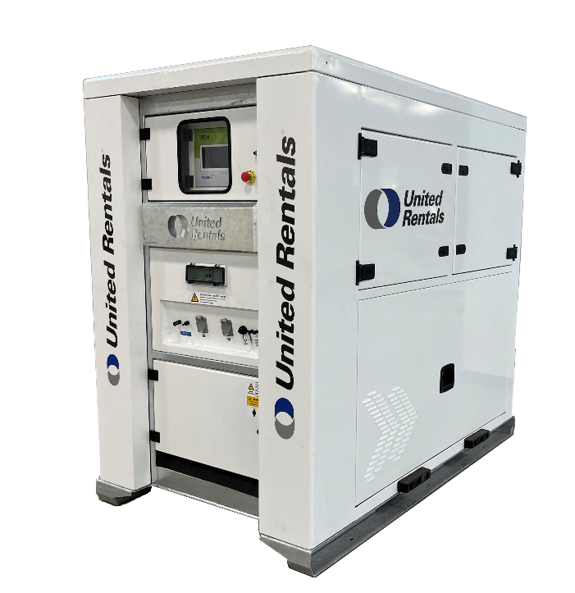

Clean, Reliable, Portable Energy Storage
Decrease Fuel Consumption, Eliminate Noise, Reduce CO₂ Emissions, Improve Energy Efficiency

Features  - Intelligent onboard energy control module that communicates with the generator  - Flexible maneuverability options with forklift pockets, lift & drag skid and lifting ring  - Monitor and manage energy online | Benefits  - Environmentally friendly, helps in meeting emissions regulations and sustainability goals  - Save on fuel, reducing both CO₂ emissions and costs  - Increases reliability as it manages variable loads and eliminates light load periods  - Delivers zero noise, ideal for projects where sound needs to be kept to a minimum
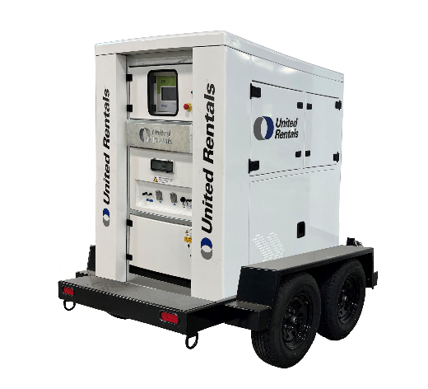
GENERAL
CAT / CLASS | 240-4845
Manufacturer
Unit Model Number | X60.120/S/H/UR
Equipment Insurance Value | $
Dimensions | 2250 mm x 1300 mm x 2065 mm (L/W/H)
Unit Weight (Est.) | 2700kg
Trailer Type | Dual Axle Trailer

Electrical
Single Point Power Supply | Input: 208 (173-242) V Output: 208 V, 60Hz – 3 Phase
Connections | CAM Type Connectors, Power Terminals & NEMA (5-15P) 15A 120V inlet  CAM Type Connectors, Power Terminals & NEMA (5-15P) 15A 120V outlet
Output Power | 60kVA - (30min), 48kW Nominal
Nominal Capacity | 128kWh
Charge Time | 3hr45 @ 31.5kW Input
Discharge Time | 5hr30 (With External Source + Storage) ,1hr45 (With Storage)
Maximum Output Current(A/ph) | 350A (External + Storage), 166.67A (Storage)
Life Cycle/Charge Cycle | 6000hr / <4 Weeks
Control & Communication | ECM 7” Touch Screen Module – 3G/4G Dual Sim Modem/Router, POWR2 Portal
Operating Temperature Range | 10 – 122 ⁰
Water/Ingress Protection Rating | NEMA 3, IP55
Battery Chemistry | LFP Batteries with BMS

Charge Curve
Charge time within a nominal temperature range is approximately three hours

Discharge Curve

